Software Requirements
Specification
For

Tulasi Building a chatbot for our college using RAG
Version 1.0 approved

Prepared by Chat Genix Keshav Memorial Institute of Technology

Copyright © 1999 by Karl E. Wiegers. Permission is granted to use, modify, and distribute this document.

Table of Contents
Table of Contents ii
Revision History ii
- Introduction 1
  - Purpose 1
  - Document Conventions 1
  - Intended Audience and Reading Suggestions 1
  - Product Scope 1
  - References 1
- Overall Description 2
  - Product Perspective 2
  - Product Functions 2
  - User Classes and Characteristics 2
  - Operating Environment 2
  - Design and Implementation Constraints 2
  - User Documentation 2
  - Assumptions and Dependencies 3
- External Interface Requirements 3
  - User Interfaces 3
  - Hardware Interfaces 3
  - Software Interfaces 3
  - Communications Interfaces 3
- System Features 4
  - System Feature 1 4
  - System Feature 2 (and so on) 4
  - System Feature 3………………………………………………………………………………………….5
  - System Feature 4 …………………………………………………………………………………………5
- Other Nonfunctional Requirements 5
  - Performance Requirements 5
  - Safety Requirements 5
  - Security Requirements 6
  - Software Quality Attributes 6
  - Business Rules 6
- Other Requirements 7
Appendix A: Glossary 7
Appendix B: Analysis Models 7
Appendix C: To Be Determined List 7

Revision History

Name | Date | Reason For Changes | Version

Introduction

Purpose

The purpose of this Software Requirements Specification (SRS) describes the development of an AI-powered chatbot specifically designed for KMIT College. The chatbot provides students, faculty, and visitors with instant and accurate information regarding academics, events, departments, and other college services. The chatbot will use LLM (Large Language Model) and RAG (Retrieval-Augmented Generation) to give smart, accurate responses. It will be powered by Lang Chain for adaptive interaction and will use cloud storage(Supabase) to manage and access data easily and securely. The chatbot also features voice assistant integration, eliminating the need for manual typing.

Document Conventions
This document follows standard IEEE SRS formatting. Key conventions include:

- Bold text for section headings.
- Italicized text for emphasis on critical terms.
- Monospace font for code snippets or technical terms.

All functional requirements are labeled as REQ-# for easy reference.

Intended Audience and Reading Suggestions

This SRS is intended for the following stakeholders:
- Developers: To implement the chatbot’s features and ensure it functions as expected.
- College Administration: To review the chatbot’s scope and ensure it aligns with college needs.
- Testers: To validate that the chatbot meets functional and non-functional requirements.
- End Users: To understand how the chatbot will help them access college-related information easily.

Product Scope
The KMIT College Chatbot is an AI-powered virtual assistant designed to simplify access to college-related information for students, faculty, staff, and prospective joiners. It leverages Large Language Models (LLM) and RAG (Retrieval-Augmented Generation) to provide intelligent, real-time responses. The chatbot will answer queries about departments, faculty info, events, clubs, and more. It will also offer features like event notifications, map-based directions to the college, and general guidance for new users. The system will be cloud-based and supported by Lang Chain for adaptive interaction, aiming to reduce the need for manual browsing on the college website.

References
This project refers to:

IEEE Standard for Software Requirements Specifications (IEEE 830-1998).
- Flask official documentation: https://flask.palletsprojects.com
- Supabase Documentation: https://supabase.com/docs

Overall Description

Product Perspective

The KMIT Chatbot is an AI-driven, voice-enabled assistant that operates across web and mobile platforms. It aims to streamline common student queries and administrative support through natural interaction. Unlike traditional search-based systems, this chatbot allows spoken queries and provides relevant responses using NLP (Natural Language Processing).
It will be implemented as a client-server model, where:
- The frontend (web/mobile) captures voice or text input.
- The backend processes user input using AI/ML models.
- A voice recognition engine like Google's Speech-to-Text converts speech to text.
- Responses are delivered in text.

Product Functions

The KMIT Chatbot is an AI-driven, voice-enabled assistant that operates across web and mobile platforms. It aims to streamline common student queries and administrative support through natural interaction. Unlike traditional search-based systems, this chatbot allows spoken queries and provides relevant responses using NLP (Natural Language Processing).
It will be implemented as a client-server model, where:
- The frontend (web/mobile) captures voice or text input.
- The backend processes user input using AI/ML models , we are using cloud service supabase for backend.
- Responses are delivered in text.

User Classes and Characteristics
- Students: Primary users seeking academic info, syllabus details, or results. Prefer quick, mobile-friendly, voice-interactive UI.
- Faculty: Use chatbot to get class schedules.
- Visitors/Parents: Ask about admissions, placements, infrastructure, fees.

Operating Environment
The chatbot works across web, mobile, and tablet devices with internet access. It combines software tools to offer real-time responses and smooth interaction. The frontend is built using Vite and TypeScript, while the backend uses Python with Flask to handle chatbot logic and web scraping. Beautiful Soup is used to scrape the data from KMIT’s website. All user data and chats are managed using Supabase, which offers secure authentication, database storage, and real-time updates.

Design and Implementation Constraints
The system must handle real-time query processing and fast response generation. It should use optimized algorithms for natural language understanding and web scraping. Performance depends on server capabilities and internet speed.The chatbot design should be scalable to support more users, features, and future integrations without affecting performance.

  - Assumptions and Dependencies
The system assumes users have stable internet access to interact with the chatbot in real-time. It depends on browser compatibility to support the web interface on both mobile and desktop devices. Supa base must be online and accessible for database operations like storing chats and user inputs. Web scraping using Beautiful Soup assumes that the KMIT website structure remains consistent for accurate data extraction. Python Flask server must be continuously running to process queries and return responses instantly.

External Interface Requirements

User Interfaces
The KMIT College Chatbot features a responsive and user-friendly web-based interface designed to work seamlessly across desktops, tablets, and mobile devices. The interface includes a chat window where users can interact with the chatbot using either text or voice input. This voice assistant functionality allows users to speak their queries, improving accessibility and ease of use. The chatbot responds instantly by displaying answers, relevant links, or announcements in the conversation window. Additionally, the system includes an admin panel where authorized users can manage content such as FAQs, student queries, and automated responses. The interface prioritizes simplicity, clarity, and ease of navigation to enhance the overall user experience for students, faculty, and visitors.

Hardware Interfaces

The chatbot operates entirely through standard computing devices such as web, desktops, etc, without requiring any additional hardware components. However, for voice assistant features, the system depends on a microphone-equipped device that supports modern web browsers with speech recognition APIs. Internet connectivity is essential to access the chatbot platform and communicate with the backend server. Since the system is web-based, it is designed to work on a variety of hardware platforms, making it accessible and flexible for users with different devices and configurations.

Software Interfaces
The chatbot system is built using Python and Flask, which handle the core logic and API routing. It integrates with BeautifulSoup for web scraping to collect live data, such as events and announcements, from trusted KMIT sources. All user inputs, chatbot responses, and admin-managed content are stored in Supabase, a cloud-based backend-as-a-service platform that provides a PostgreSQL database, authentication, and real-time synchronization. The backend may expose RESTful APIs to enable integration with external apps or portals for data access and chatbot responses.

Communications Interfaces
The chatbot requires an active internet connection for sending and receiving messages between the frontend and backend. Communication is handled using secure protocols such as HTTPS for REST APIs. The system supports multiple platforms (desktop, tablet, mobile), ensuring smooth interactions across devices.

System Features
  - Real-Time Chat Response

Description and Priority
The chatbot responds to student queries instantly using natural language processing. This feature is high-priority, as it ensures smooth and intelligent communication between users and the system.

Stimulus/Response Sequences
      - A user types a question into the chat interface.
      - The system receives the message and analyzes it.
      - A relevant answer is generated based on stored data or scraped content.
      - The chatbot sends the response back to the user instantly.
      - The query and response are logged in the database.

Functional Requirements

REQ-1: The chatbot shall provide real-time responses to user questions.

REQ-2: The chatbot shall understand natural language input.

REQ-3: The chatbot shall provide accurate and relevant information.

  - Web Scraping for Updates

Description and Priority
The chatbot automatically fetches latest updates like notices or events from the official KMIT website using web scraping. This is a high-priority feature for keeping students informed.

Stimulus/Response Sequences
      - A user asks for the latest announcements
      - The system uses BeautifulSoup to scrape updates from the college website.
      - Scraped content is processed and formatted.
      - The chatbot shares the update with the user.

Functional Requirements

REQ-4: The system shall scrape updates from predefined KMIT websites.
REQ-5: The chatbot shall deliver fresh and accurate scraped content.
REQ-6: The system shall avoid duplicate or outdated announcements.

  - Drop-Down Menu

Description and Priority

This feature involves a drop down menu in the chatbot where the user can solve their queries with help of pre-defined queries by which the output can be more accurate to what user wants

Stimulus/Response Sequences
      - The user clicks the related option from drop down menu.
      - The chatbot narrows down the options and if there are any new options.it displays them. If the keyboard input is neccessary it allows the user to type the prompt.

Functional Requirements

- User Interaction – The chatbot displays a dropdown menu with predefined query options. The user can select an option. If there are no relevant options, the chatbot allows users to type query manually.
- Query Generation – The chatbot maps each dropdown option to specific query. It fetches and displays information related to selected option.
- Error Handling – The chatbot will not allow submission of query until no option is selected. If the selected option fetches no response, it displays an error message.

  - Secure Cloud Data Logging

Description and Priority

All user interactions and admin actions are securely stored in the cloud using Supabase. This is a high-priority feature for data management and review.

Stimulus/Response Sequences
      - A chat interaction occurs between user and bot.
      - System logs query, response, and timestamp.
      - Admin updates or reviews chatbot content.
      - System logs admin actions in the database.

Functional Requirements

REQ-7: The system shall store chat history with timestamps in Supabase.
REQ-8: The system shall log all admin updates and actions.
REQ-9: The system shall allow review of past interactions for improvement.

Other Nonfunctional Requirements

Performance Requirements

The chatbot system should respond quickly and smoothly to ensure a good user experience. It must handle multiple user queries efficiently and keep response time low even during peak usage. The chatbot should respond to user queries within 5 second on average. It should handle multiple users simultaneously without crashing or slowing down. Web scraping using BeautifulSoup should fetch content in near real-time.

Safety Requirements

The system must follow data safety guidelines to prevent misuse or data loss. User information and chat history must be handled with care. All stored data should be protected from unauthorized access.If the system fails or crashes, it should log the failure and notify the admin. Regular data backups should be taken using Supabase .Admin dashboard should have restricted access to avoid accidental data loss

Security Requirements

User data and admin access must be secure. Authentication is required for admins to access the dashboard. All data transfer (e.g., between frontend and backend) should use HTTPS. The system should log all admin actions and user queries for monitoring. If someone tries to access restricted areas without permission, the system should send a security alert

Software Quality Attributes
The chatbot system should be reliable, scalable, easy to maintain, and user-friendly. The system must work continuously without crashing. It should handle more users or additional features without slowing down. The code should be modular and easy to update or fix. The interface should be simple and intuitive for all users.

Business Rules

Rules that control who can use and modify the chatbot data and how alerts are handled. Only authorized users can change chatbot settings or access logs. Users can customize notifications according to their preferences. The system must follow data privacy laws to protect user data.

Other Requirements
Any other requirements that are stumbled upon will be duly listed here.
Language support: Multilingual support may be added in future releases to support non-English speakers.

Appendix A: Glossary

AI (Artificial Intelligence) – Machines simulating human intelligence, used for tasks like understanding and responding in chatbots

Beautiful Soup: A Python library used to scrape and parse live web data.

Flask – A lightweight Python framework used to create the chatbot’s backend server.

Supa base: A backend service for authentication, database management, and real-time updates.

Natural Language Processing (NLP): Technology that helps the chatbot understand and respond to human language.

API (Application Programming Interface): A set of rules allowing different software parts to communicate.

Appendix B: Analysis Models

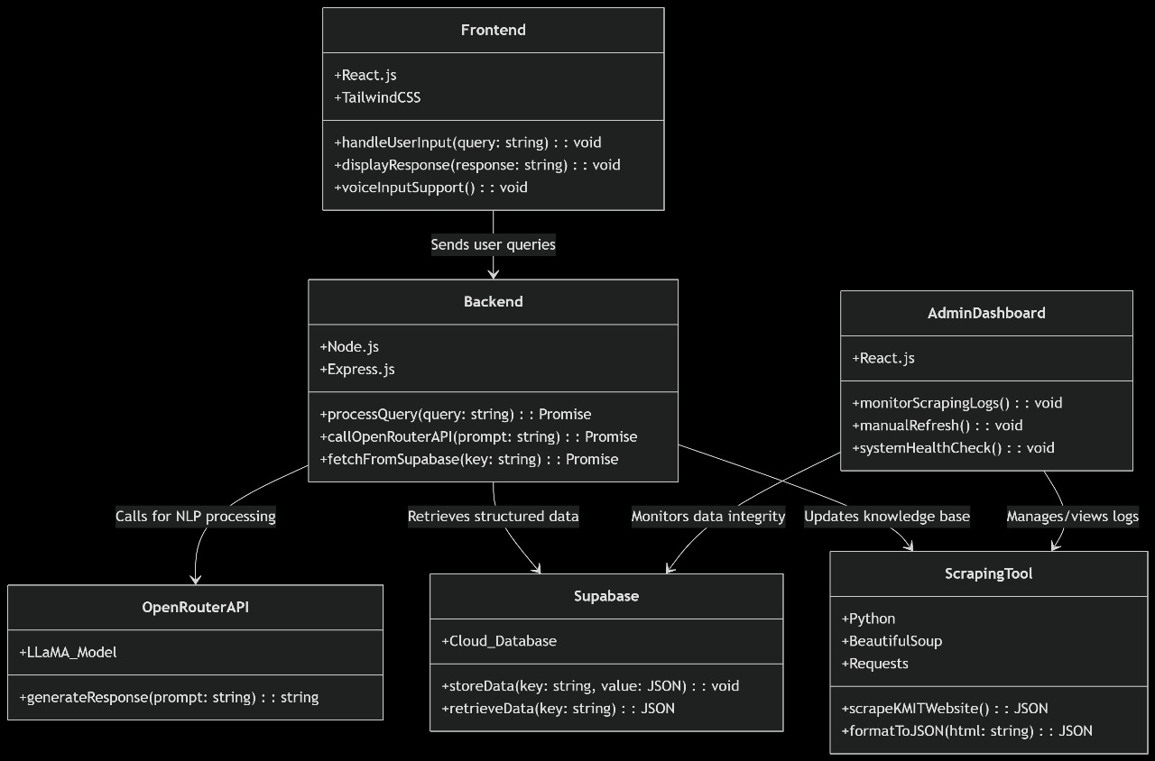
-Flask
-Lang Chain

